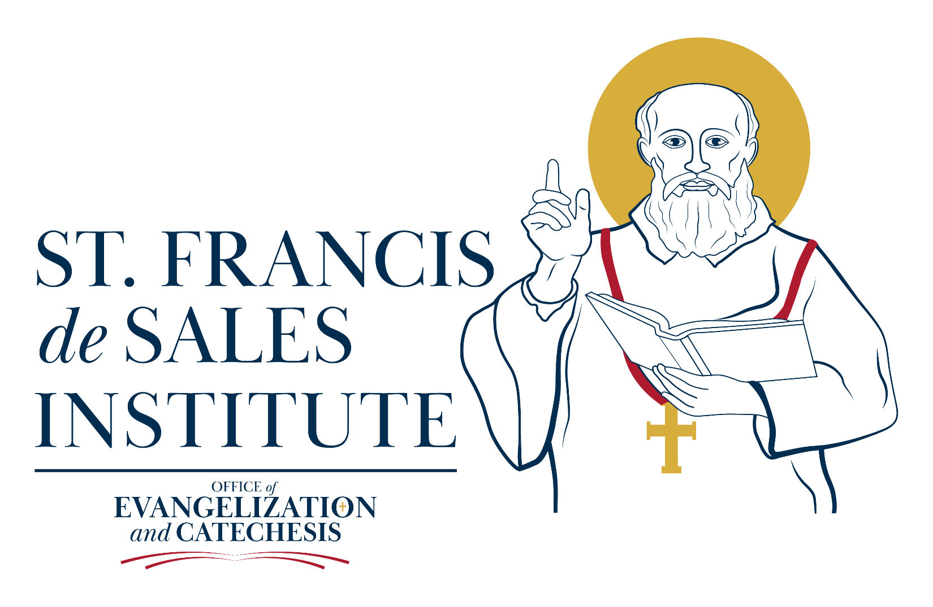

Catechist Formation Program
A Brief Overview

Course Objectives
The objective of the Catechist Formation Program is to prepare the catechist to be an effective witness and teacher of the Gospel of Jesus Christ. The aim of all Catechetical instruction is to place the student in an intimate relationship with Jesus Christ. (CT, 5, 20)
One of the main tenets of this program is to assist the catechist in forming and developing sound catechetical lesson plans that will draw the student toward a closer relationship with Jesus Christ. Throughout this program, emphasis is placed on using sound resources such as Sacred Scripture, the Catechism of the Catholic Church, Magisterial Catechetical documents e.g. General Director for Catechesis, Catechesis In Our Time, Evangelization in the Modern World, and so on.
In the end, the catechist will hopefully come away with a sound catechetical foundation, enabling him/her to transmit the Gospel with rigor and vigor.
Catechist Requirements
Catechists are required to:
- Participate in all required sessions (9) to complete Level 1 (Basic)of the Catechist Formation Program
- Complete one doctrinal lesson plan. This will be explained in detail in the sessions.
- Participate in one Diocesan-sponsored catechetical workshops, lectures, or presentations
- Complete and submit an assessment exam. (optional)
Textbooks
Required
The Holy Bible Revised Standard Version 2nd ed.; Ignatius Press (2006), San Francisco.*
Catechism of the Catholic Church 2nd ed.; USCCB (2002), Washington D.C.*
Recommended
Catechesis In Our Time; Pope John Paul II; Daughters of St. Paul (1979) New York
The Catechism of the Catholic Church and the Craft of Catechesis; Morgan, Willey, De Cointet; Ignatius Press (2008), San Francisco
The Mystery We Proclaim 2nd ed.; Msgr. Francis Kelly, Our Sunday Visitor (2000), Huntington, IN
General Directory for Catechesis; Congregation for the Clergy; Libreria Vaticana Editrice (1997)
National Directory for Catechesis: Pontifical Council for the Promotion of the New Evangelization; Our Sunday Visitor, (2020).

Catechetical credit hours
There are a total of nine sessions required to complete Level 1 Basic Catechist Certification. The breakdown of credit hours is as follows:
- Each Session equals 3 credit hours, except for the last session, which is valued at six credit hours.

- (9) Sessions x (3) credit hours for a total of 30 Credit hours. Note: Session Nine counts for six credit hours.

- Completion of one (1) well-crafted doctrinal lesson plans: 10 Credit Hours.

- Participation in one approved Diocesan Catechetical workshops, conferences, or lectures: 10 Credit Hours.*(Examples of Approved Diocesan Events are: Evangelization Summit, National Catechetical Conferences, i.e., St. John Bosco Conference, NCCL, NCEA, etc.

- Total credit hours needed to complete Basic Catechist Certification: 50 credit hours.

Fees
There is a one-time fee of $75.00 per catechist. This fee covers all nine sessions including all handouts and the student workbook which will be provided at the first session.
Please Note: The fee does not cover the “required textbooks” (Bible and Catechism).

Diocesan Tuition Assistance
There is very limited tuition assistance for catechists participating in the program. Tuition assistance will be based on the degree of financial need per catechist on a first come first serve basis.

Parish Financial Assistance
All catechists should inquire with their Pastor or Director of Religious Education about tuition assistance to participate in the program.
Length of the program
The average length of the program will be one year. Please note: students may be able to finish the program sooner depending on scheduling and availability of instructors, host sites, etc.

The Curriculum
Lesson One: What is Catechetics?
This lesson will go over a basic understanding of the ministry of catechesis, what catechetical instruction is, and the art of teaching the Catholic faith in a clear and organized way.
Lesson Two: The Content of Catechesis
This lesson will concentrate on teaching the Content of Catechesis centered on Jesus Christ. Particular emphasis is placed on Sacred Tradition, Sacred Scripture, and the use of the Catechism of the Catholic Church.
Lesson Three: Teaching the story through Sacred Scripture.
This lesson will guide the catechist on how to proclaim and effectively teach the Story of Salvation i.e., Salvation History as part of the yearly catechetical curriculum. Emphasis is placed on how we are part of God’s plan as children of God.
Lesson Four: Using the Ocia as a model of instruction
This session will cover how to use the RCIA model to instruct your children in the Catholic faith. Emphasis will be placed on the general structure of the RCIA process.
Lesson Five: Teaching from the Catechism
The lesson will guide the catechist on how to effectively use the Catechism of the Catholic Church in their catechetical instruction.
Lesson Six: Teaching the Liturgy and the sacraments
This lesson will cover basic points on how to effectively teach from and with the Liturgy and effectively articulate the seven sacraments of the Catholic Church.
Lesson Seven: Teaching According to Age
This lesson will guide catechists on how to effectively teach at various grade levels. Emphasis will be placed on sound pedagogical principles to enhance the lesson.
Lesson Eight: Teaching Methods in Catechesis
This lesson will cover multiple teaching methods to assist the catechists in developing sound catechetical principles while teaching.
Lesson Nine: Developing Your Curriculum
The aim of this last lesson is to assist the catechist in putting everything together to develop a sound lesson plan and curriculum for their religious education class.

How This Program Works

Introduction
Anyone who desires to teach the Catholic faith knows that you just can’t get by with what you know at face value. There are intricacies in teaching the Catholic faith that are both basic and substantive. In other words, merely knowing the Catholic does not necessarily mean it will transform someone into a master teacher.
The art of teaching the Catholic faith involves many facets on the part of the catechist, e.g., the ability to study the Church and grasp what the Church teaches, i.e., knowing creedal, doctrinal, sacramental, liturgical, moral, and spiritual foundations well. Besides these tenets, a good teacher will become well-versed in foundational sources such as Sacred Scripture and the Catechism of the Catholic Church. Grasping these foundational truths is part of what makes a sound catechist- a person who hands on the teachings of Jesus Christ and His Church. Another important is the authentic witness of the catechist, which in reality should be primary when teaching others. Actively living the Gospel in fidelity fosters the two-fold foundation of sound catechesis and sound witness of the faith for others.
The aim of the St. Francis De Sales Basic Catechist Formation Program is to form catechists. A catechist is a person who desires to teach the Catholic faith and become an effective witness of the Gospel. The primary emphasis of this program is to form faithful catechists. Throughout this journey, catechists will become familiar with basic catechetical concepts; understand the role of the liturgy, the RCIA process, the Catechism of the Catholic Church, proper methodology, lesson planning, and so forth in the areas of catechesis and catechetical instruction.
I hope that anyone who participates in this program will gain a better awareness and appreciation of catechesis and the central role it plays in forming the Catholic faithful to develop an intimate relationship with Jesus Christ with a love that is never-ending.

God did not create you because He had any need of you, for you are wholly useless to Him, but only that He might exercise towards you His goodness, bestowing on you His grace and glory. To accomplish this, he has given you an understanding to know Him, a memory to remember Him, a will to love Him, an imagination to recall His mercies, eyes to see the wonders of His works, a tongue to praise Him, and so with all your other faculties. Therefore, being created and placed in the world for this purpose, you should avoid and reject all actions which are contrary to it, and despise as idle and superfluous all which do not promote it.
St. Francis De Sales, Introduction to the Devout Life

